Novel Catalysts (Type Your Title Here – Times New Roman 10 pt Bold)

John A. Author¹ (underline presenting author) and Susan Q. Author-Two²*
¹(Italics, 8pt) Super University, Anytown, Anystate 55555 (Country)
²Fundamental Research Laboratory, Excellent Company, Site Location,
Anytown, Anystate 44444-2222 (Country)
*s.a-t@excellentco.com (corresponding author designated with a star)

Introduction
A variety of information may be provided to introduce the topic. Citations to the relevant prior literature are appropriate [1], whether they are citations to the chemical problem, or the techniques employed in the study [2]. Note the formatting of in-text citations and formatting for references in the Reference Section. Commonly accepted abbreviations should be employed. Examples of abbreviation formats include: 1000-4000 ppm, 2 – 5 wt% Pd/Al₂O₃, 50 m²/g, TOF = 4.26x10⁴ h⁻¹, (authors are encouraged to determine concentration of catalytically active surface sites and to report activity normalized, i.e., as turnover frequencies), 1640 cm⁻¹, 225 °C, (note: MS Word has a degree symbol, which is preferred over a superscripted “o”), 20% conv., LHSV = 0.2 h⁻¹ (i.e., 0.2 cc/(cc_{cat} h)) [3,4]. All acronyms should be defined upon first mention.

Not adhering to the following may preclude the abstract from review. Section headings may not be altered or removed. The first paragraph of every section is indented but subsequent paragraphs within a section are not. One empty line must be left between paragraphs. The document has margins: Top and Bottom: 1.25” (3.18 cm), Left and Right: 1” (2.54 cm). All text should be in Times New Roman font, 8 pt size, single line spacing, and full justification [4].

Materials and Methods
This section serves as the “Experimental” section for laboratory studies. Brief descriptions of chemicals and equipment should be supplied, along with descriptions of experimental procedures, analytical tools, and methods of data analysis. For studies that are exclusively theoretical or computational, descriptions of relevant software packages, basis sets, data analysis tools, etc should be supplied.

Results and Discussion
Brief descriptions of key results should be supplied along with discussion of relevant conclusion, mechanistic insights, and other inferences. When incorporating figures and data tables, the items should remain within the boundaries of one column of text. Figures and tables should be numbered sequentially with captions given below figures and titles above tables. Text within the figure should not be sized less than 8 pt font. It is best to use conventional formats for artwork (*.tif, *.jpeg, *.gif etc and Microsoft Office-compatible software) but authors are advised that determining the compatibility of artwork with Adobe Acrobat to create a *.pdf file is their responsibility. The preparation of *.pdf files ensures retention of document formatting across most computer platforms.

Table 1. Surface composition via ESCA
Catalyst | %C | %N | %Ni | N / Ni
Ni – A5 | 39.8 | 5.2 | 12.7 | 0.41
Ni –control | 24.3 | 0.2 | 18.4 | 0.01

Presented data should be described, briefly interpreted, and related to the problem under study.

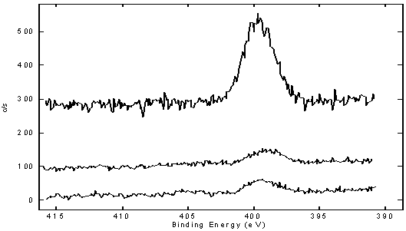
(A)
(B)
(D)
(C)
Figure 1. ESCA data for four catalysts used in hydrogenation of chemical XYZ A) Ni – A5, B) Ni – control, C) Ni – A6, D) Ni – A7. Text wrapping may be used around figures. All figure content should be legible if abstract is printed on letter-size paper.

Significance
Authors should briefly highlight industrial and/or fundamental significance of the work.

References
- Anonymous, Oil and Gas Journal 98, 26 (2000).
- Knudsen, K.G., Cooper, B.H., and Topsoe, H. Appl. Catal. A: General 189, 205 (1999). Note the formatting for journal article references.
- Allgeier, A.M., and Duch, M.W. in “Chemical Industries (Catalysis of Organic Reactions” (M.E. Ford, Ed.) Vol. 82 p. 229. Marcel Dekker, New York, 2001. Note the formatting for excerpts from books.
- National Petroleum Refiners Association. Fuel Quality—Hydroprocessing, Q&A Session Minutes. Washington, D.C., National Petroleum Refiners Association (1998).
Only references that have been published in the open literature or are in press should be included in the References section. Use journal title abbreviations commonly employed by the Chemical Abstract Service. The abbreviation “et al.” may be used after the third author.

